

**CREATING A PROBLEM SOLVING ALGEBRIC CHATBOT**

**PROJECT CREATED BY:**

**YOGESHWARI** .**D**

**PRIYADHARSHINI** **.R**

**SELVI.D**

**RESHMA.B**

**PROJECT CODE:DT001**

**TEAM NAME:DT 163**

**REFERENCES: Dr .V. Sitadevi**

Executive summary:

A chatbot can be defined as a virtual assistant that acts as an intelligent intermediary between people, digital systems and internet-enabled things. It replaces the traditional graphical user interfaces(GUIs) of an application or website with a “conversational user interface”. It is a paradigm shift from the earlier communications achieved either by entering syntax- specific commands or clicking icons. Chatbots can be designed to chat with people through a mix of natural language- based conversations, and responses can come in the form of buttons, calendars or other widgets that accelerate the speed with which a person can respond. Creating a chatbot involves designing a conversational interfaces that can interact with users. Key points in this project include defining the chatbot’s purposes. The chat bots is used for solving algebraic problems. The designing of the chatbot is by using the HTML, CSS ,JAVASCRIPT as a front end for the chatbot. And for the backend use of advanced python as flask transformers , pip and tensor flow. The conversation flow of the chatbot is by using simple English statements.by implementing a NLP(natural language processing) for understanding user input and integrating with backend systems. Findings may include user engagement metrices, accuracy of responses, and user satisfaction. Conclusions could involve improvements in the chatbot’s design, functionality, or user experience. Recommendations may focus on enhancing NLP capabilities, expanding the chatbot’s features, or optimizing its performance based on user feedback. The key for a conversational bot to understand humans and extract relevant information from the user utterance. NLP(natural language processing) is the science of extracting the intention (intent) of text and relevant information (entity) from the text. Managing dialogues to keep track multiple conversation threads, remembering the context and responding to the user tone or sentiment helps in giving the much needed humane touch the conversation and at the same time serving the user with accurate and appropriate responses.

Table of contents:

Contents:

**Project title…………………………………………………………………………….**

Executive summary:…………………………………………………………….

Table of contents:…………………………………………………………………

Project objective:………………………………………………………………….

Scope:………………………………………………………………………………………

Methodology:………………………………………………………………………....

Artifacts used:……………………………………………………………………….

Technical coverage:…………………..………………………………………..

Results:…………………………………………………………………………………..

Challenges and resolutions:…………………………………………….

Questionnaire:………………………………………………………………………

Conclusion:……………………………………………………………………………

References:………………………………………………………………………….

Project objective:

The project objective of creating a chatbot to solve algebraic problems is to develop a virtual assistant that can help users with their algebraic equations and calculations. The chatbot’s main goal is to provide step-by-step solutions to algebraic problems, guide users through solving equations, and offer explanations for various algebraic concepts. By creating this specialized chatbot, the aim is to assist users in understanding and solving algebraic problems more effectively and efficiently through interactive conversations and explanations.

**Scope:**

The scope of chatbot can vary depending on its design and purpose. Chatbots like chatgpt are virtual assistants that can help with a wide range of topics such as answering questions, providing information, assisting with tasks, and even engaging in conversations. Some chatbots are designed for customer service, while others are created for educational purposes or entertainment. In essence, the scope of a chatbot is defined by its programming capabilities, allowing it to fulfil specific roles effectively. The scope of a chatbot refers to the range of task and functions it can perform.

DIFFERENT TYPES OF CHATBOTS:

RULE-BASED CHATBOTS:

These chatbots follow predefined rules and are programmed with specific responses based on keywords or phrases. They are more limited in their capabilities and usually used for simple tasks like answering FAQs or providing basic information.

AI-POWERED CHATBOTS:

These chatbots are artificial intelligence and machine learning algorithms to understand and response to user queries. They can analyze language, learn from interactions, and provide more personalized responses. AI chatbots are more advanced and can handle complex conversations.

HYBRID CHATBOTS:

These chatbots combine rule based and AI-powered approaches. They use rules for straightforward queries and switch to AI algorithms for more complex interactions. Hybrid chatbots offer a balance between structured responses and adaptive learning.

**Methodology of chatbot:**

DEFINE THE PURPOSE:

The purpose of the chatbot is by solving any math complex algebraic problems thus the design of the chat bots is based on the python implementation.

CHOOSE THE CHATBOT TYPE:

The chatbot type is based on the AI powered chatbot.

DESIGN OF CONVERSATIONAL FLOW:

The conversational flow is based on the input that is given and the chatbot is user friendly

DEVELOP PROBLEM SOLVING ALGORITHMS:

Creation of algorithms for the chatbot is by the natural language processing (NLP).

TEST AND ITERATE:

The testing of chat bots accuracy is important in how they play a role in day to day life.

DEPLOY AND MONITOR:

Once the chatbot is ready, deploy it on the desired platform. Monitor its performance, analyze the user interactions, and make adjustments to enhance its problem-solving abilities over time.

**Empathy map:**

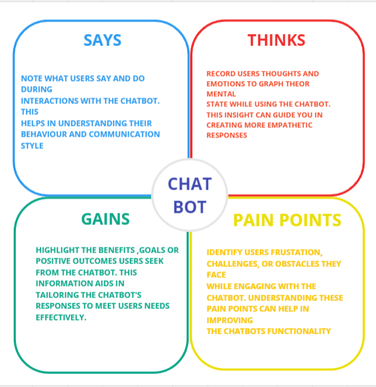

**ARTIFACTS USED IN CHATBOT:**

Natural language processing (NLP) is a key artifact that enables chatbots to understand and interrupt human language. It helps chatbots analyze user inputs, extract meaning, and generate apprpirate responses.

Machine learning models is algorithm are used to train chatbots to improve their performance over time .these models help chatbots learn from user interactions and provide more accurate responses.

Decision trees are used to create a structured flow of conversation within the chatbot. They help determine the appropriate responses based on user inputs and guide the chatbots to different scenarios.

APLs application programming allow chatbots to access external data sources are services to provide users with real- time information or perform specific task like weather updates, language translation, are ecommerce transaction.

Dialogue- management systems helps chatbot maintain context during conversation, manage multiple intents , and handle complex dialogues effectively.

**TECHNICAL COVERAGE:**

The languages that is used in the chatbots are advanced python with torch tensor flow transformations with the front end languages as HTML, CSS, JAVASCRIPT are used chatbots creation.

**SOURCE CODE:**

**STEPS USED IN CHATBOT CREATION:** **![Binaryhood](Logo/BinaryhoodLogo.png)**

**# ChatBot**

**## Installation & Setup**

**[Install Python] https://www.dataquest.io/blog/installing-python-on-mac/**

**[Install pip] https://phoenixnap.com/kb/install-pip-mac**

**If you have Python & pip installed then check their version in the terminal or command line tools**

**```**

**python3 --version**

**```**

**```**

**pip --version**

**```**

**## Installing Flask**

**In your terminal run the requirements.txt file using this pip**

**```**

**pip install -r requirements.txt**

**```**

**## Running ChatBot Application in Terminal**

**```**

**cd into your directory**

**```**

**```**

**python app.py**

**```**

**## What you will create**

**In this tutorial, I will guide you through the process of building a chatbot that can carry out conversations with users using natural language processing.**

**To start, we will be using Microsoft DialoGPT, a pre-trained language model that can generate human-like responses to given prompts. We will be integrating DialoGPT with Flask, a popular Python web framework, to create a web application that can communicate with users via a chat interface.**

**For the frontend of our application, we will be using HTML, CSS, and JavaScript to create a visually appealing and interactive chat interface. Additionally, we will be using jQuery to handle the HTTP requests that are made to the backend server.**

**Throughout the tutorial, I will provide step-by-step instructions on how to set up your development environment, install the necessary dependencies, and create the required files and code for the application. I will also explain how to train and fine-tune the DialoGPT model to improve the accuracy of its responses.**

**By the end of this tutorial, you will have a fully functional chatbot that can engage in conversations with users, and you will have gained valuable experience in using Microsoft DialoGPT, Flask, and web development technologies such as HTML, CSS, and JavaScript.**

**# ChatBot Link**

**The Chatbot is constructed using the Microsoft/DialoGPT-medium model.**

**```**

**https://huggingface.co/microsoft/DialoGPT-medium**

**```**

**# User-Html**

**```**

**var userHtml = '<div class="d-flex justify-content-end mb-4"><div class="msg_cotainer_send">' + user_input + '<span class="msg_time_send">'+ time +**

**'</span></div><div class="img_cont_msg"><img src="https://i.ibb.co/d5b84Xw/Untitled-design.png" class="rounded-circle user_img_msg"></div></div>';**

**```**

**# Bot-HTML**

**```**

**var botHtml = '<div class="d-flex justify-content-start mb-4"><div class="img_cont_msg"><img src="https://i.ibb.co/fSNP7Rz/icons8-chatgpt-512.png" class="rounded-circle user_img_msg"></div><div class="msg_cotainer">' + bot_response + '<span class="msg_time">' + time + '</span></div></div>';**

**```**

**FRONT END:**

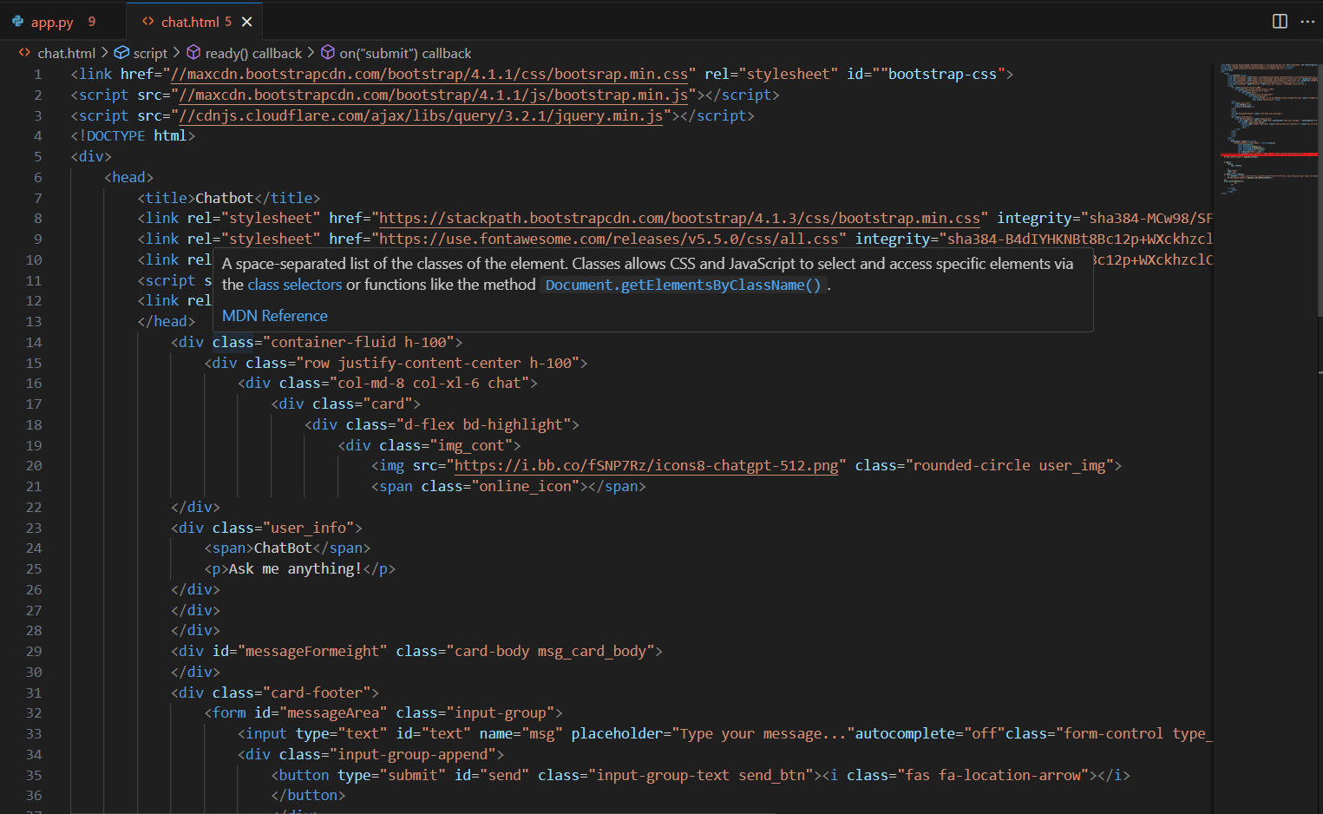

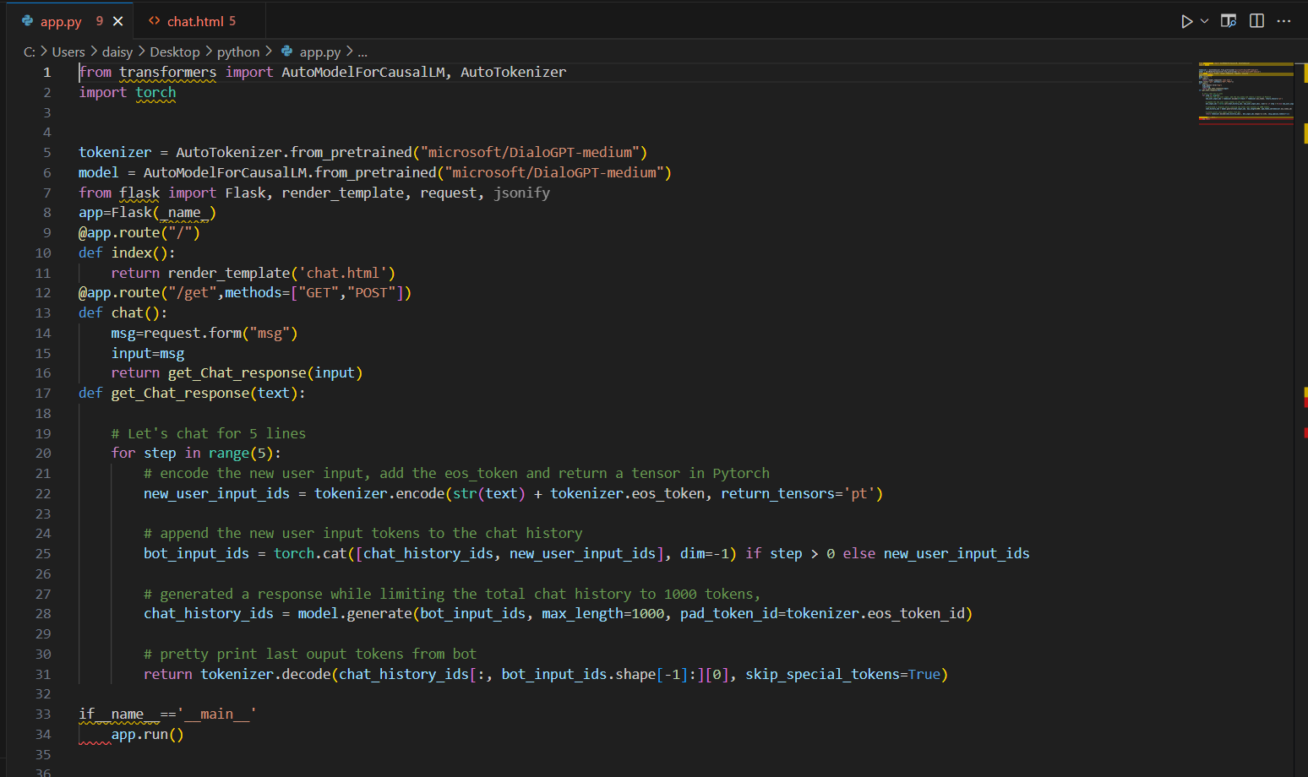

**INSTALLING OF FLASK TRANSFORMERS AND TORCH:**

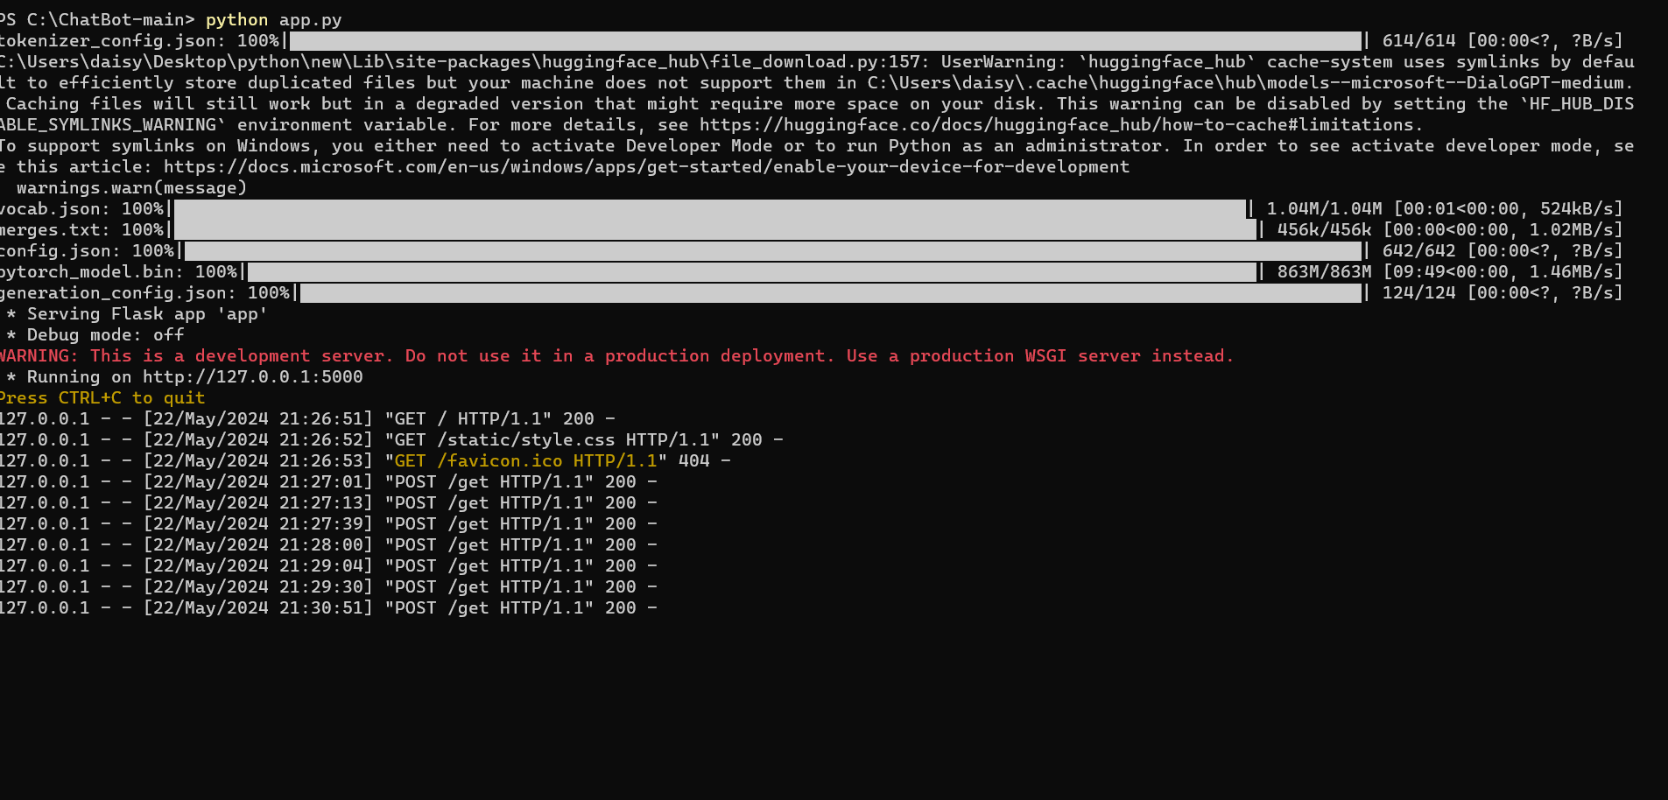

**STYLE IN CSS:**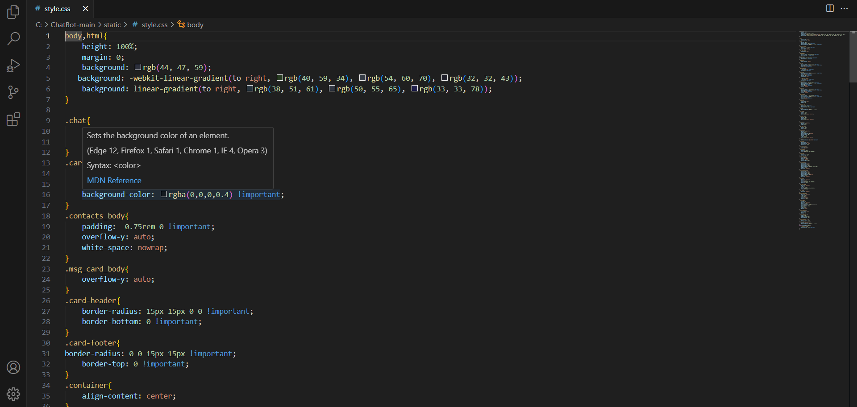

**LOGO:**

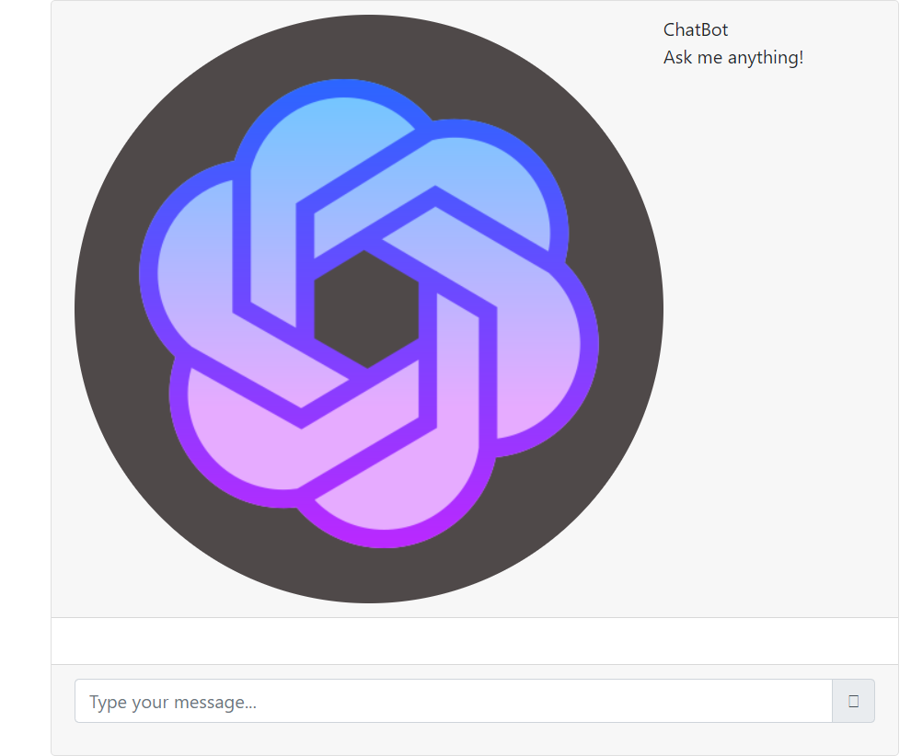

**SURVEY REPORTS:**

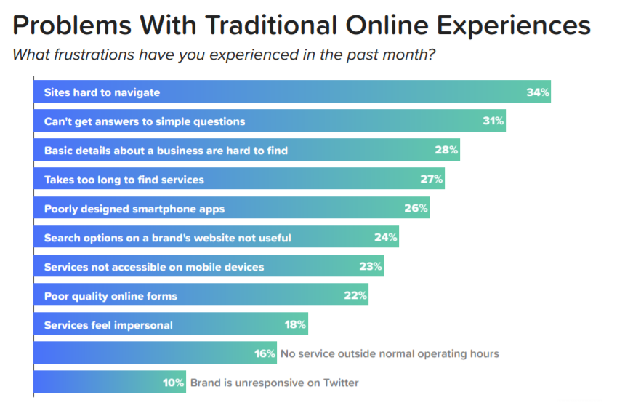

**RESULTS OF CHATBOT** :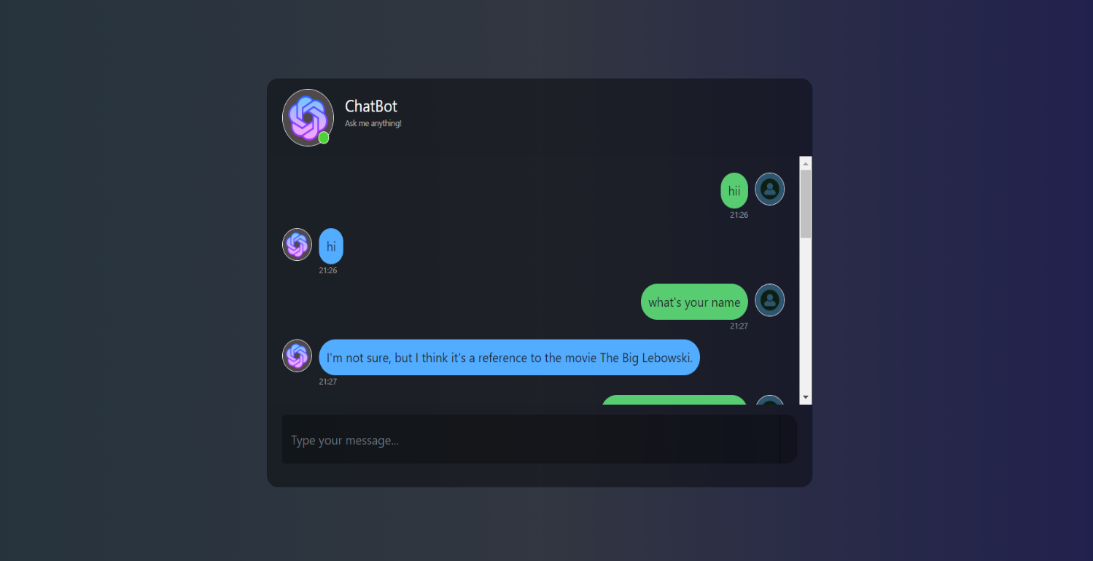

BENEFITS OF CHATBOT:

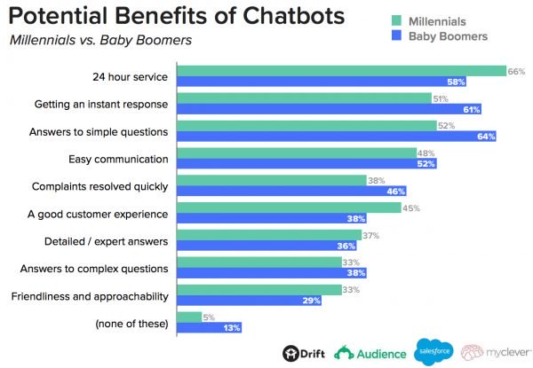

CHALLENGES AND RESOLUTIONS:

**1. Empathize:**

UNDERSTAND THE CHALLENGES AND PREFERNCES OF STUDENTS LIKE LILY REGARDING ACCESSING LECTURE NOTES AND STUDY RESOURCES

Organization: keeping track of various lecture notes, hand- outs, and study material can be real struggle. It’s important to have a system that allows for easy organizations and retrieval of these resources.

Accessibility: students often need to access their study materials from different devices or locations. Having a solution that allows for seamless access across devices and platforms is crucial.

Searchability: when you have ton of notes and, finding specific information quickly can be time- consuming. A search function that allows you to search within your documents can be a game – changer.

Collaboration: some times, studying with peers or getting input from classmates can be really helpful. Having features that enable collaboration and sharing of study materials can enhance the learning experience.

Personalization: every student has their own unique study preferences and techniques. As solution that allows for customization and personalization can cater to individual needs and enhance the productivity.

By understanding these challenges and preferences, we can design a resource library prototype that addresses these pain points and provides a user – friendly, efficient, and personalized studying experience.

**2.Define:**

SYNTHESIZE THE GATHERED DATA TO DEFINE SPECIFIC REQUIREMENTS AND FEATURES FOR THE RESOURCES LIBRARY PROTOTYPE

Document types: students find lecture notes, practise exam, textbooks, and supplemented materials like study guides and flashcards to be the most helpful for exam preparation. so, the resource library should support these document types.

Accessibility: students prefer having access to study materials across multiple devices, such as smartphones, tablets and laptops. The resource library should have a responsive design and be a accessible through web and mobile platforms.

Organization: students mentioned the importance of having a system to organize their study resources. The resource library should include features like folders, tags, and search functionality to make it easy to find and categorize documents.

Collaboration: some students expressed the desire to collaborate with peer on study materials. It could be beneficial to include features that allow for shared note- taking, document sharing, and discussion forums.

Personalization: students have different learning styles and preferences. The resource library should provide option for customization, such as highlighting, annotating, and book marking, to cater to individual study needs.

Integration: students mentioned the convenience of integrating the resource library with other tools they use, such as note- taking apps, calendar apps, and learning management systems. integration capabilities could enhance the overall studying experience.

IDENTIFY THE TYPES OF DOCUMENTS TEACHERS TYPICALLY SHARE WITH STUDENTS, SUCH AS LECTURE SLIDES, HAND OUTS, READING MATERIAL, AND SUPPLEMENTARY RESOURCES.

Define categories or tags to organize the documents based on subject, topic, or exam date to facilitate easy navigation and retrieval

Some common examples include lecture slides, handouts, reading materials, and supplementary resources like study guides or practise problems.

To facilitate easy navigation and retrieval, we can define categories or tags based on subject, topic, or exam date. This way students can quickly find the specific documents they need for a particular subject or topic. for example, we can have categories like ‘mathematics’, ‘science’, ‘English’, and within each category, tags for specific topics like ‘algebra’, ‘biology’, ‘literature’. Additionally, tag based on exam dates can help students locate materials relevant to upcoming exam.

**3.IDEATE:**

Brainstorm and generate ideas for the layout and functionality of the resource library prototype.

Explore the different approaches for document categorization, search functionality, and user interface design to optimize usability and efficiency

Consider features such as favourites or bookmarks, document previews, and notifications for new uploads to enhance the user experience

Document categorization: we can use a sidebar or dropdown menu to display the different categories or subjects. Within each category we can have subcategories or tags for specific topics. This way, users can easily navigate and locate the documents they need.

Search functionality: implement a search bar at the top of the resource library interface. Users can enter keywords, document titles, or tags to quickly find relevant materials. We can also consider incorporating advanced search filters, such as sorting by date, filetype or author.

User interface design: aim for a clean and intuitive design with a grid or list view to display the documents. Each document can have a thumbnail or preview image, title, and relevant details. Users can click on a document to access its content or additional information.

favorites or bookmarks: allow users to mark documents as favorites or bookmark them for easy access later. This feature can help students keep. track of their most frequently used or important resources

Document previews: provide a preview option for documents, such as lecture slides or PDFs, so users can quickly glance at the content before deciding to

Download or view the full document.

Notifications for new uploads: implement a notification system to alert users when new documents are uploaded in their subscribed categories or when new materials are added by their teachers. This way, students can stay updated and never miss out on important resources.

**4. prototype**

Develop a of the resource library to visualize and test various design ideas.

Design wireframes or mockups of the user interface, showcasing the layout, navigation structure, and interaction elements of the prototype.

Use prototyping tools to create interactive demos that stimulate the user experience of browsing, searching, and accessing documents within the resource library.

Once we have the design ready, we can use prototyping tools like Adobe XD, Figma, or Invision to create interactive demos. these

Demos will simulate the user experience of browsing, searching, and accessing documents within the resource library. We can add clickable buttons, search bars, and navigation elements to make it feel like a real application.

**5.TEST:**

Gather feedback from students like lily through usability testing and user feedback sessions.

Evaluate the effectiveness of the resource library prototype in meeting their needs and preferences for accessing study resources.

Identify any usability issues or areas for improvement based on user insights and feedback

To test the prototype, we can gather feedback from students like you through usability testing and user feedback sessions. We can observe how you interact with the prototype, listen to your thoughts, and note any difficulties or areas where improvements can be made.

**6.Implement**

Translate the finalized design of the resource library prototype into code.

Integrate the prototype into the app, platform, ensuring seamless functionality and compatibility with different devices and operating systems.

Conduct thorough testing to validate the performance and reliability of the resource library in real- world usage scenarios.

This involves writing the necessary HTML,CSS, and JAVASCRIPT code to bring the prototype to life.

After the code is ready, we’ll integrate the prototype into the app platform, ensuring that it functions seamlessly and is compatible with different devices and operating systems. This way, students and teachers can access the resource library, or computer.

To ensure the performance and reliability of the resource library in real- world scenarios, we’ll conduct thorough testing. The testing will help us identify and fix any bugs or issues that may arise, ensuring a smooth user experience

**7.Evaluate:**

Monitor the usage and feedback of students using the resource library after deployment

Collect feedback from both teachers and students on the effectiveness of the library in sharing and accessing study resources.

Continuously iterate and update the library based on user feedback and evolving needs to enhance its usefulness and usability over time.

Once the resource library is deployed, we’ll monitor its usage and gather feedback from students and teachers. Their insights will be invaluable in evaluating the effectiveness of the library in sharing and accessing study resources. We’ll continuously iterate and update the library based on this feedback and evolving needs, making it even more useful and user- friendly over time.

**RESOLUTIONS:**

Accuracy: ensuring that the chatbots responses are accurate and relevant to the users queries is essential for resolution. This involves training the chatbot with high- quality data and continuously refining it algorithm to improve response accuracy.

Personalization: personalizing responses based on user preferences history , or context can enhance the chatbots resolution capabilities. By offering tailored suggestions are information, the chatbot can provide more meaningful assistants to users.

Feedback mechanism: implementing feedback mechanisms allows users to provide input on the chatbots responses. This feedback loop helps to improve the chatbots performance overtime and enhances its resolutions capabilities

Multi turn conversations: supporting multi turn conversations enables the chatbot to handle complex queries that require multiple interactions by maintaining context and guiding users through a series of steps, the chatbot effectively resolve more intricate issues.

Continuous learning: leveraging machine learning algorithms and natural language processing techniques allowsthe chatbot to learn from user interactions and adapt to new information. Continuous learning improves the chatbots resolution capabilities by expanding its knowledge based and refining its responses.

**Questionnaire:**

1.WHAT IS THE PUROPSE OF THE CHATBOT?

THE PURPOSE OF THE CHATBOT IS TO ANSWER THE PROBLEMS FOR MATHEMATICAL ALGEBRAIC PROBLEMS.

2.WHAT ARE THE GOALS FOR CHATBOT?

THE GOALS OF THE CHAT BOT IS USERFRIENDLY AND CAN BE IN THE EASY CONVERSATIONAL FLOW.

3. WHO WILL BE USING YOUR CHATBOT?

THE STUDENTS WHO WANTS TO SOLVE PROBLEMS AND THE TEACHERS WHO TEACHES THE STUDENDTS CAN USE THE CHATBOT.

4.WHERE WILL YOU DEPLOY THE CHATBOT ?

WE WILL DEPLOY THE CHATBOTS SOON IN THE WEBSITES AS OFFICIAL.

5.HOW WILL YOU MEASURE YOUR SUCCESS ?

WE HAVE 50 %ACCURACY IN OUR CHATBOTS WE ARE IMPLENTING IT WITH 99% ACCURACY.

**CONCLUSION:**

Chatbots play a vital role in providing personalised assistance, gathering feedback, and enhancing user experience through questionnaires. By utilising accurate responses, personalization, feedback mechanism, multi turn conversation, and continuous learning, chatbots can effectively resolve user queries and offer tailored support the use of questionnaires helps gather user information, preferences and feedback to further improve the chatbots performance. Overall chatbots are valuable tools that continue to evolve to meet user needs and enhanceinteraction experiences.

**REFERENCES OF CHATBOT:**

Research papers: academic journals and conference proceeding often publish research papers on chatbot technologies, their applications, and advancements in the field

Online articles: websites like tele crush, Forbes, and wired frequently cover topics related to chatbots, offering insights to industry trends, case studios, and best practices.

Chatbot development platform: platforms like dialog flow, Microsoft bot framework and IBM Watson provide documentation, tutorials, and resources for building and deploying chatbots

Chatbot blocks: many company’s that specialize in chatbot development maintain blocks that discuss industry news, tips for chatbots design , and case studios showcasing successful in implementations.

Chatbot conferences: attending conferences such as chatbots summit and conversational interactions conference can provide valuable insights into the latest trends and innovations in the chatbots space.

THANK YOU